SITESAFE CONSTRUCTION SAFETY SYSTEM
A PROJECT REPORT
Submitted by
VINESH D
(240701590)
in partial fulfilment of the End Semester Examination for the course
CB23F35 –
LOW-CODE APPLICATION DEVELOPMENT USING ZOHO CREATOR
in
BACHELOR OF ENGINEERING
COMPUTER SCIENCE AND ENGINEERING


RAJALAKSHMI ENGINEERING COLLEGE
(An Autonomous Institution, Affiliated to Anna University, Chennai)
Rajalakshmi Nagar, Thandalam, Tamil Nadu – 602 105

NOVEMBER 2026

RAJALAKSHMI ENGINEERING COLLEGE
(An Autonomous Institution, Affiliated to Anna University, Chennai)

BONAFIDE CERTIFICATE
Certified that this project report titled “SITESAFE CONSTRUCTION SAFETY SYSTEM” is the bonafide work of VINESH D (240701590), who carried out the individual project work on the Zoho Creator low-code platform for the course CB23F35 – Low-Code Application Development using Zoho Creator, during the academic year 2026–2027, Semester V, under my supervision.

SIGNATURE | SIGNATURE
Dr. J. Manoranjini | Dr. J. Jinu Sophia
HEAD OF THE DEPARTMENT | Assistant Professor
Department of Computer Science and Engineering | COURSE FACULTY
Rajalakshmi Engineering College | Department of Computer Science and Engineering
Thandalam – 602 105 | Rajalakshmi Engineering College

Submitted for the End Semester Examination (Individual Project) held on ______________________________.

INTERNAL EXAMINER | EXTERNAL EXAMINER

DECLARATION
I, VINESH D (240701590), hereby declare that the project report titled “SITESAFE CONSTRUCTION SAFETY SYSTEM”, submitted for the End Semester Examination of the course CB23F35 – Low-Code Application Development using Zoho Creator, is a record of original work carried out by me individually. The Zoho Creator configuration described in this report — including its forms, reports, dashboard, Deluge workflow, Blueprints, role profiles and assistant definition — is documented from the supplied application export.
I further declare that this work has not been submitted, in part or in full, for the award of any other degree or course credit. Every template, sample application, AI-assisted feature, code snippet, or external resource used in this work has been duly acknowledged in the report.

Place: Chennai
Date:
SIGNATURE OF THE STUDENT
VINESH D
240701590

ACKNOWLEDGEMENT
I express my sincere gratitude to our Chairman Mr. S. Meganathan, Chairperson Dr. (Mrs.) Thangam Meganathan, and Vice-Chairman Mr. M. Abhay Shankar for providing the infrastructure and facilities that made this work possible.
I am grateful to our Principal, Dr. S. N. Murugesan, Rajalakshmi Engineering College, for the constant encouragement extended to students to take up industry-relevant learning.
I thank Dr. J. Manoranjini, Head of the Department, Department of Computer Science and Engineering, for the guidance and support provided throughout the course.
I owe my sincere thanks to my course faculty, Dr. J. Jinu Sophia, Assistant Professor, for the valuable guidance, reviews, and feedback that shaped this application and report.
I also acknowledge Zoho Corporation for providing access to the Zoho Creator platform and its learning resources, and I thank my family and peers for their continuous support.
VINESH D

ABSTRACT
Construction environments require continuous monitoring of physical site safety, regulatory compliance, hazard reporting, and operational task permits. In standard construction workflows, safety logs, physical inspections, contractor details, and work permits are maintained in disparate paper logs or standalone spreadsheets. This decentralised record-keeping can delay the mitigation of serious site hazards, weaken verification of mandatory safety permits, and fragment communication between contractors and project managers.
This project presents the SiteSafe Construction Safety System, developed on the Zoho Creator low-code platform. The application is organised around six core forms: Site Registry, Hazard Register, Safety Inspections, Work Permit Management, Corrective Action Tracker, and AI Insights Log. Lookup relationships connect site records with inspections, hazards, corrective actions, permits and AI insights. One Deluge workflow assigns a site safety status from the open-hazard count; Blueprints define the hazard and permit stages. The export includes an embedded conversational Site Safety Assistant. It does not show a configured external integration or an automated AI hazard-analysis workflow.
The export defines six forms, six list reports, six Kanban reports, one dashboard, two Blueprints, one Deluge site-status workflow, a conversational assistant, and several permission profiles. The export contains configuration rather than execution evidence, so test outcomes are not reported as completed. SiteSafe demonstrates how a low-code platform can organise construction safety records and define repeatable operational processes.
Keywords: Low-Code Development; Zoho Creator; Construction Safety; Deluge Scripting; Workflow Automation; Blueprints; Role-Based Access Control; Conversational Assistant.

PROJECT AT A GLANCE
Attribute | Details
Project Title | SiteSafe Construction Safety System
Application Domain | Construction Safety Operations and Regulatory Compliance Management
Student Name & Register No. | VINESH D – 240701590
Zoho Creator Edition | Zoho Creator export; live edition not identified
Application Name (Link Name) | SiteSafe Construction Safety System
Published / Live URL | Not included in export
Demo Credentials (per role) | Not included in export
Number of Forms / Subforms | 6 forms; no subforms shown
Number of Reports (by type) | List: 6; Kanban: 6
Number of Pages / Dashboards | 1 dashboard page
Number of Workflows | 1 explicit Deluge workflow; 2 Blueprints; no scheduled workflow shown
Deluge Functions / Actions | Site-status validation script; no other Deluge functions shown
Integrations | No external service connection shown
AI Components | Site Safety Assistant; AI-labelled fields and AI Insights Log; no model invocation shown
Roles & Profiles Defined | 9 profiles listed in the export; see access-control section
Environments Used | Workspace/deployment status not established by export
Date of Deployment | Export generated 10-Nov-2026; deployment date not established

TABLE OF CONTENTS
CHAPTER 1 INTRODUCTION ............................................. 1
1.1 Background ...................................................... 1
1.2 Problem Statement ............................................... 1
1.3 Objectives ...................................................... 2
1.4 Scope of the Project ............................................ 2
1.5 Justification for a Low-Code Approach ........................... 3
1.6 Organisation of the Report ...................................... 3
CHAPTER 2 LITERATURE SURVEY AND SYSTEM STUDY ....................... 4
2.1 Study of the Existing System .................................... 4
2.2 Limitations of the Existing System .............................. 5
2.3 Low-Code versus Traditional Development ......................... 5
2.4 Literature Survey ............................................... 6
2.5 Emerging Trends in Low-Code Development ......................... 7
2.6 Proposed System ................................................. 8
CHAPTER 3 REQUIREMENT ANALYSIS ..................................... 9
3.1 Stakeholders and User Roles ..................................... 9
3.2 Functional Requirements ......................................... 10
3.3 Non-Functional Requirements ..................................... 11
3.4 Hardware and Software Requirements .............................. 11
3.5 Use Case Model .................................................. 12
CHAPTER 4 SYSTEM DESIGN ............................................ 14
4.1 System Architecture ............................................. 14
4.2 Data Model and ER Design ........................................ 15
4.3 Form Specifications ............................................. 16
4.4 Process and Workflow Design ..................................... 21
4.5 User Interface and Navigation Design ............................ 23
4.6 Access Control and Security Design .............................. 24
CHAPTER 5 IMPLEMENTATION ON ZOHO CREATOR ........................... 26
5.1 Application Setup ............................................... 26
5.2 Forms and Data Model Implementation ............................. 26
5.3 Reports and Dashboard Implementation ............................ 28
5.4 Workflow and Blueprint Implementation ........................... 29
5.5 Deluge Scripting ................................................ 30
5.6 Integration Status ............................................ 31
5.7 Conversational AI and Assistant Setup ........................... 32
5.8 User Roles and Security Configuration ........................... 33
CHAPTER 6 TESTING AND DEBUGGING .................................... 34
6.1 Test Strategy ................................................... 34
6.2 Verification Cases and Evidence Status ................................ 34
6.3 User Acceptance Testing ......................................... 36
6.4 Debugging and Defect Log ........................................ 37
CHAPTER 7 DEPLOYMENT, OPTIMISATION, SECURITY AND GOVERNANCE ........ 38
7.1 Deployment and Environment Strategy ............................. 38
7.2 Performance Optimisation ........................................ 38
7.3 Security and Governance Controls ................................ 39
CHAPTER 8 RESULTS AND DISCUSSION ................................... 41
8.1 Achievement of Objectives ....................................... 41
8.2 Comparison with the Existing System ............................. 42
8.3 Discussion of Results ........................................... 43
8.4 Limitations ..................................................... 43
8.5 Low-Code Reflection ............................................. 44
CHAPTER 9 CONCLUSION AND FUTURE ENHANCEMENTS ....................... 45
9.1 Conclusion ...................................................... 45
9.2 Future Enhancements ............................................. 45
9.3 Learning Outcomes and Career Pathways ........................... 46
REFERENCES .......................................................... 47
APPENDIX A – ZOHO CREATOR FEATURE COVERAGE CHECKLIST ................ 48
APPENDIX B – COURSE OUTCOME MAPPING ................................. 50
APPENDIX C – COMPLETE DELUGE SOURCE CODE ............................ 51
APPENDIX D – USER MANUAL ............................................ 54
APPENDIX E – EVALUATION RUBRIC ...................................... 56
APPENDIX F – VIVA-VOCE RECORD SHEET ................................. 58

LIST OF FIGURES
Figure 2.1: As-Is Process Flow of the Existing System
Figure 3.1: Use Case Diagram of the Application
Figure 4.1: System Architecture of the Application
Figure 4.2: Entity–Relationship Diagram
Figure 4.3: Hazard Resolution Lifecycle
Figure 4.4: Work Permit Authorisation Lifecycle
Figure 4.5: Dashboard Navigation and Information Layout

LIST OF TABLES
Table 2.1: Comparison of Low-Code and Traditional Development
Table 2.2: Summary of Literature Survey
Table 3.1: Stakeholders and User Roles
Table 3.2: Functional Requirements
Table 3.3: Non-Functional Requirements
Table 3.4: Hardware and Software Requirements
Table 3.5: Use Case Description
Table 4.1: Entities and Relational Structure
Tables 4.2–4.4: Form Field Specifications
Table 4.5: Role–Permission Matrix
Table 5.1: Reports Implemented in SiteSafe
Table 6.1: System Test Cases and Results
Table 6.2: Defect Log
Table 8.1: Mapping of Objectives to Outcomes
Table 8.2: Existing System versus SiteSafe
Table A.1: Feature Coverage Checklist
Table B.1: Course Outcome Mapping
Table E.1: Evaluation Rubric
Table F.1: Viva-Voce Questions

LIST OF ABBREVIATIONS
Abbreviation | Expansion
AI | Artificial Intelligence
API | Application Programming Interface
CRM | Customer Relationship Management
CRUD | Create, Read, Update, Delete
ER | Entity–Relationship
FR | Functional Requirement
IDE | Integrated Development Environment
KPI | Key Performance Indicator
LCAP | Low-Code Application Platform
NFR | Non-Functional Requirement
OAuth | Open Authorisation
RBAC | Role-Based Access Control
REST | Representational State Transfer
UAT | User Acceptance Testing
UI | User Interface

CHAPTER 1
INTRODUCTION

1.1 Background
The construction industry operates under dynamic and potentially hazardous conditions. On active job sites, safety engineers, general contractors, equipment operators, and project managers must comply with occupational health and safety requirements. Daily operations involve inspecting site perimeters, monitoring heavy equipment, validating high-risk work permits such as electrical isolations, hot work, scaffolding and confined-space entry, and addressing emerging environmental hazards.
Traditionally, safety logs and inspection checklists are recorded on physical clipboards or in separate spreadsheets. When safety audits are captured on paper, safety coordinators cannot quickly compile incident metrics or enforce timely mitigation protocols. Critical issues, such as missing safety barriers or unverified machinery certifications, may go unnoticed across large projects. Maintaining visibility across multiple sites therefore requires a centralised application that connects field data collection with administrative oversight.

1.2 Problem Statement
Handling safety operations across construction projects manually or through standalone spreadsheets introduces operational delays and regulatory risks. The main issues identified are:
- Siloed Site Records: Project parameters, contractor details and site hazard histories are documented in isolated spreadsheets, making it difficult to maintain a unified site safety status.
- Unenforced Permit Workflows: High-risk tasks may proceed without structured multi-stage safety sign-offs, weakening the consistency of workplace controls.
- Delayed Hazard Remediation: Corrective actions are tracked informally, resulting in missed due dates and unverified closures.
- Disjointed Contractor Information: Contractor contact details, qualifications and work permits are not consistently connected with corporate relationship systems.
- Lack of Executive Visibility: Project managers lack timely visibility into open hazards across job sites, making proactive intervention difficult.

1.3 Objectives
- Design a relational data model in Zoho Creator consisting of Site Registry, Hazard Register, Safety Inspections, Work Permit Management, Corrective Action Tracker and AI Insights Log forms.
- Implement multi-stage Blueprints to govern hazard mitigation and permit authorisation.
- Automate site safety status evaluation (Safe, Warning, Critical) using event-driven Deluge scripts based on open hazard counts.
- Configure an embedded Site Safety Assistant for data interaction across selected safety modules.
- Deploy interactive dashboards featuring metric cards, quick-action links and category-filtered Kanban reports.
- Store AI-labelled hazard and insight fields and provide a conversational assistant; automated hazard scoring is outside the exported configuration.

1.4 Scope of the Project
In-Scope: Site registration, safety inspections, hazard records, corrective actions, work permits, AI insight records, site-status calculation, dashboards, list and Kanban reports, conversational assistance and configured role permissions. The export contains fields for evidence links and AI-labelled values; it does not show a live AI analysis or external CRM integration.
Out-of-Scope: Direct IoT sensor streams from machinery, biometric turnstile integrations, automated financial penalty processing and offline edge computing without periodic internet access.

1.5 Justification for a Low-Code Approach
Building a custom safety system using traditional frameworks requires backend architecture, user-interface development, database configuration and custom security controls. Zoho Creator provides visual data modelling, responsive application layouts, workflow triggers and platform security features. Deluge scripting adds the flexibility required for business logic and business logic. This combination supports rapid development while allowing the project to implement application-specific processes.

1.6 Organisation of the Report
Chapter 2 evaluates existing systems and low-code literature. Chapter 3 presents the requirements. Chapter 4 explains the system design and architecture. Chapter 5 documents implementation on Zoho Creator. Chapter 6 describes testing and debugging. Chapter 7 reviews deployment, security and governance. Chapter 8 discusses results and limitations, while Chapter 9 concludes the report and identifies future enhancements.

CHAPTER 2
LITERATURE SURVEY AND SYSTEM STUDY

2.1 Study of the Existing System
In a manual construction setup, safety officers carry printed audit checklists across job sites. Observations are handwritten, photographs are captured separately, and records are transcribed into desktop spreadsheets at the end of a shift. Work permits may require physical signatures, creating delays between subcontractors and safety supervisors. When an incident occurs, audits require manual searches through paper archives to reconstruct historical records.
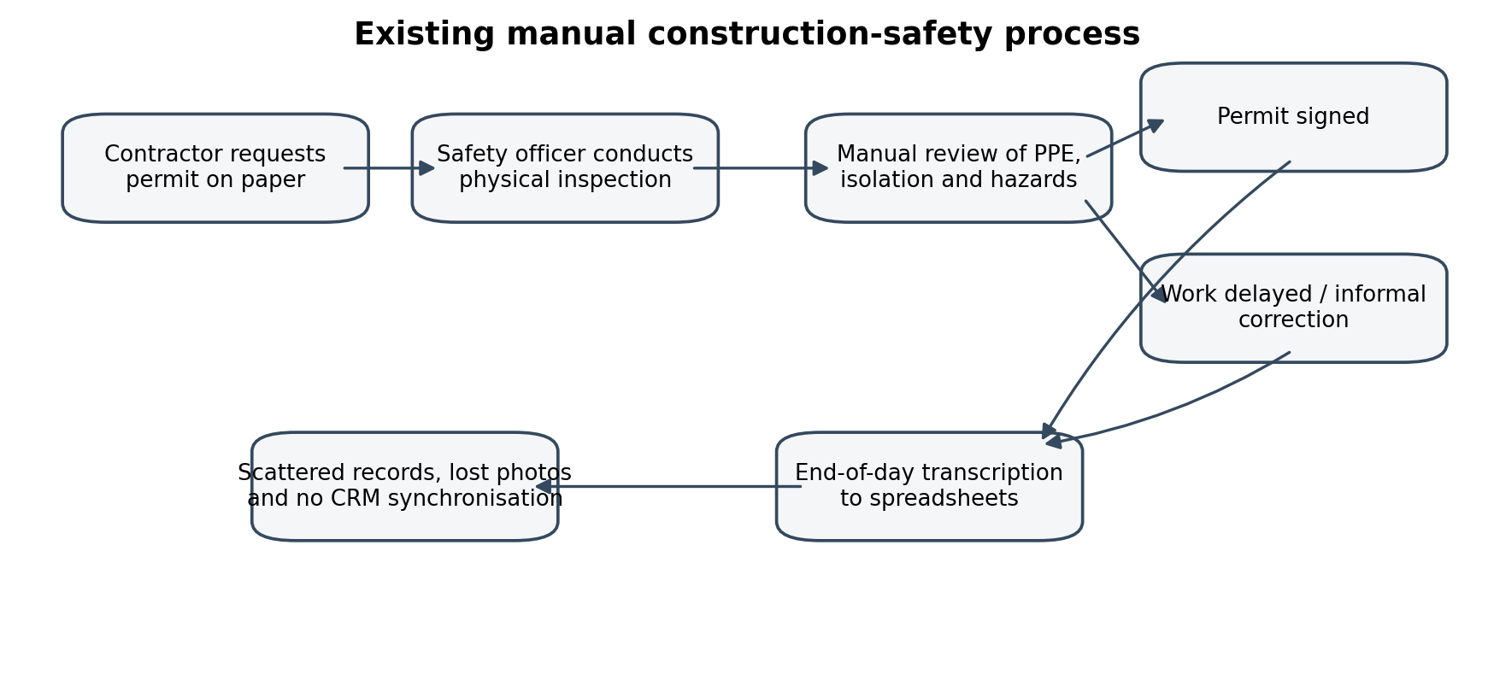
Figure 2.1: As-Is Process Flow of the Existing System

2.2 Limitations of the Existing System
- Transcription Errors and Data Loss: Manual entry can result in missing inspection records, unlinked evidence and incomplete compliance trails.
- Absence of Real-Time Escalation: Critical hazards may remain unflagged until weekly logs are aggregated.
- Unenforced Safety Stages: Permit steps can be skipped without a structured approval process.
- Fragmented Vendor Data: Subcontractor credentials and safety histories are not consistently synchronised with enterprise systems.

2.3 Low-Code versus Traditional Development
Table 2.1 contrasts conventional custom development with the low-code implementation approach adopted for SiteSafe.
Criterion | Traditional (Pro-Code) Development | Low-Code on Zoho Creator
Development Time | Custom backend, UI and database development | Visual builders, forms and Deluge reduce implementation effort
Data Relationships | Manual SQL schema, foreign keys and ORM | Built-in lookup fields and relational binding
Mobile Deployment | Dedicated application builds and responsive styling | Platform-provided mobile and tablet layouts
Lifecycle Management | Custom state tables, routing and validation | Visual Blueprints with stage-transition criteria
Security and RBAC | Custom authentication and permission middleware | Platform user permissions and profile configuration
System Integrations | Custom REST clients and token handling | No external integration is shown in the supplied export

2.4 Literature Survey
S.No. | Author(s) / Source | Title / Focus | Key Findings / Relevance
1 | A. C. Bock and U. Frank (2021) | Low-Code Platforms: Conceptual Foundations | Model-driven development supports faster enterprise application delivery; relevant to SiteSafe's visual data model.
2 | Zoho Corporation (2026) | Zoho Creator Developer Guide | Documents forms, lookups, Deluge scripting and layout customisation used in the project.
3 | M. Waszkowski (2019) | Low-code platform for automating business processes in manufacturing | Discusses low-code process automation in operational settings.
4 | D. Di Ruscio et al. (2022) | Low-code development and model-driven engineering | Examines the relationship between low-code development and model-driven engineering.
5 | Zoho Corporation (2026) | Zoho Corporation, Zoho Creator Developer Guide | Provides guidance for synchronising records with Zoho CRM.

2.5 Emerging Trends in Low-Code Development
- Hyper-Automation: Combining event-driven scripts, scheduled monitors and multi-stage process models to automate operational workflows.
- Edge Field Productivity: Supporting field personnel with mobile data capture, location details and image evidence.
- Integrated Cognitive Agents: Embedding natural-language assistants to help analyse records and present operational insights.

2.6 Proposed System
The SiteSafe Construction Safety System establishes a centralised operational environment. Six forms maintain structured records for sites, hazards, inspections, permits, corrective actions and AI insights. Lookup fields connect operational records to registered sites and related hazards. A Deluge workflow assigns site safety status from the entered open-hazard count. Blueprints define controlled hazard and permit lifecycles. The application defines a Site Safety Assistant and provides dashboards with safety indicators, charts and Kanban tracking views. No external integration is shown in the export.

CHAPTER 3
REQUIREMENT ANALYSIS

3.1 Stakeholders and User Roles
Role | Description | Responsibilities
Administrator | System controller and platform manager | Full access to application configuration, user accounts and workflows.
Site Safety Manager | Head of safety across operational sites | Monitors safety levels, corrective actions and audits.
Safety Officer | Field engineer conducting inspections | Executes checklists, logs hazards and attaches evidence.
Compliance Auditor | Internal or external safety auditor | Evaluates historical trends, closed hazards and inspection histories.
Permit Coordinator | Supervisor for high-risk tasks | Manages permit requests, checks documents and reviews approvals.
Project Manager | Manager for an individual construction project | Monitors open hazards and project-level safety information.
Contractor | Third-party trade partner or subcontractor | Submits work permits and uploads resolution evidence for assigned hazards.

3.2 Functional Requirements
FR ID | Requirement Description | Role(s) | Priority
FR-01 | Register job sites with location, assigned managers and target dates. | Administrator, Manager | High
FR-02 | Conduct safety inspections across categories with Pass/Fail results. | Safety Officer | High
FR-03 | Log hazards with severity, category and photographic resolution evidence. | Safety Officer, Contractor | High
FR-04 | Recompute site safety status based on open-hazard counts. | System Automation | High
FR-05 | Track corrective actions with owners, priorities and target dates. | Safety Manager, Contractor | High
FR-06 | Enforce multi-stage Blueprint approvals for high-risk work permits. | Permit Coordinator, Contractor | High
FR-07 | No CRM integration is shown in the supplied export. | System Integration | High
FR-08 | Conversational data assistance; no automated risk analysis is shown. | Safety Officer, Manager | Medium
FR-09 | Display KPI cards and hazard distribution charts on a dashboard. | All Internal Roles | Medium

3.3 Non-Functional Requirements
- NFR-01 Performance: Dashboard metrics and list reports should render within two seconds under standard network conditions; runtime has not been measured.
- NFR-02 Security and Access Control: Profile permissions should restrict each user to records required by their role; runtime access has not been tested.
- NFR-03 Auditability: Blueprint transitions should retain review context. A separate audit-log form is not shown in the export.
- NFR-04 Usability: The interface should support field data entry on mobile, tablet and desktop devices.

3.4 Hardware and Software Requirements
Element | Specification
Platform | Zoho Creator cloud environment (2026)
Scripting Language | Deluge
Supported Browsers | Google Chrome 120+, Mozilla Firefox and Microsoft Edge
Enterprise Connections | No external integration is defined in the supplied export.
Client Requirements | Modern web browser or Zoho Creator mobile app and an internet connection

3.5 Use Case Model
The configured user profiles include Administrator, Site Safety Manager, Safety Officer, Compliance Auditor, Permit Coordinator, Project Manager and Contractor, with Developer and Customer platform profiles also listed. No external service connection is shown in the export.
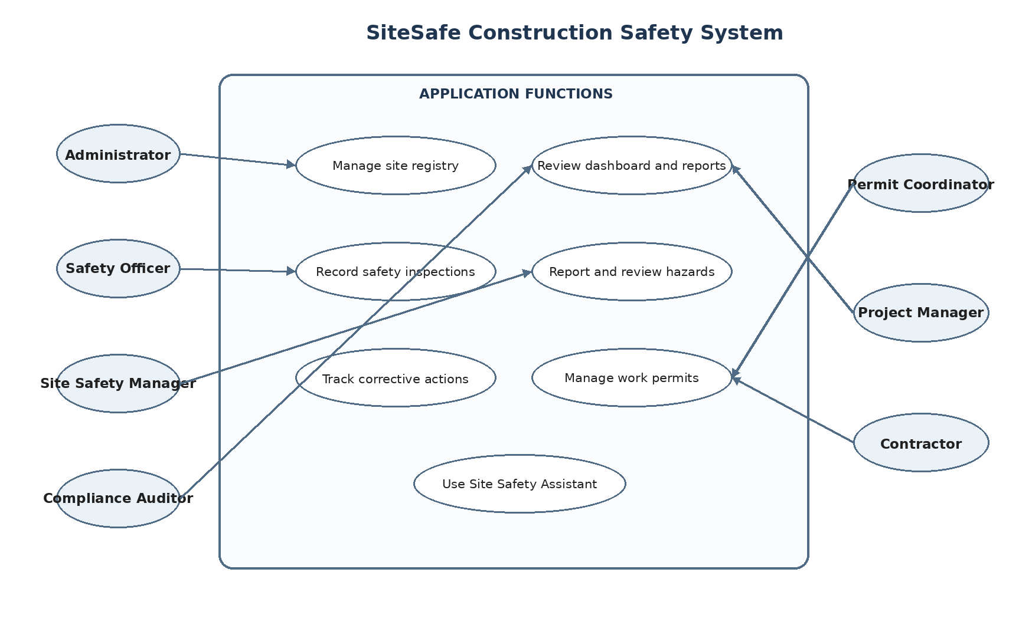
Figure 3.1: Use Case Diagram of the Application
Item | Details
Use Case ID | UC-01
Use Case Name | Log Hazard and Initiate Corrective Action
Actors | Safety Officer (Primary), Site Safety Manager and Workflow Engine
Pre-Conditions | The target site must be registered in the Site Registry.
Main Flow | 1. Select a registered site. 2. Record inspection and hazard details. 3. Link the hazard to its site and inspection. 4. Add a corrective action linked to the hazard and site when required. 5. On site validation, the entered open-hazard count maps to Safe (0), Warning (1–3) or Critical (>3). The dashboard presents configured counts, charts and the hazard report. Automatic hazard-count updates and action creation are not shown in the export.
Post-Conditions | Site status is reflected on the dashboard and the responsible person can track the remedial task.

CHAPTER 4
SYSTEM DESIGN

4.1 System Architecture
SiteSafe uses a layered cloud architecture. The presentation layer provides access through the Zoho Creator application. The application and process layer contains forms, reports, Deluge scripts, Blueprints and the conversational assistant. No external integration layer is defined in the export. Creator form records are related through lookup fields.
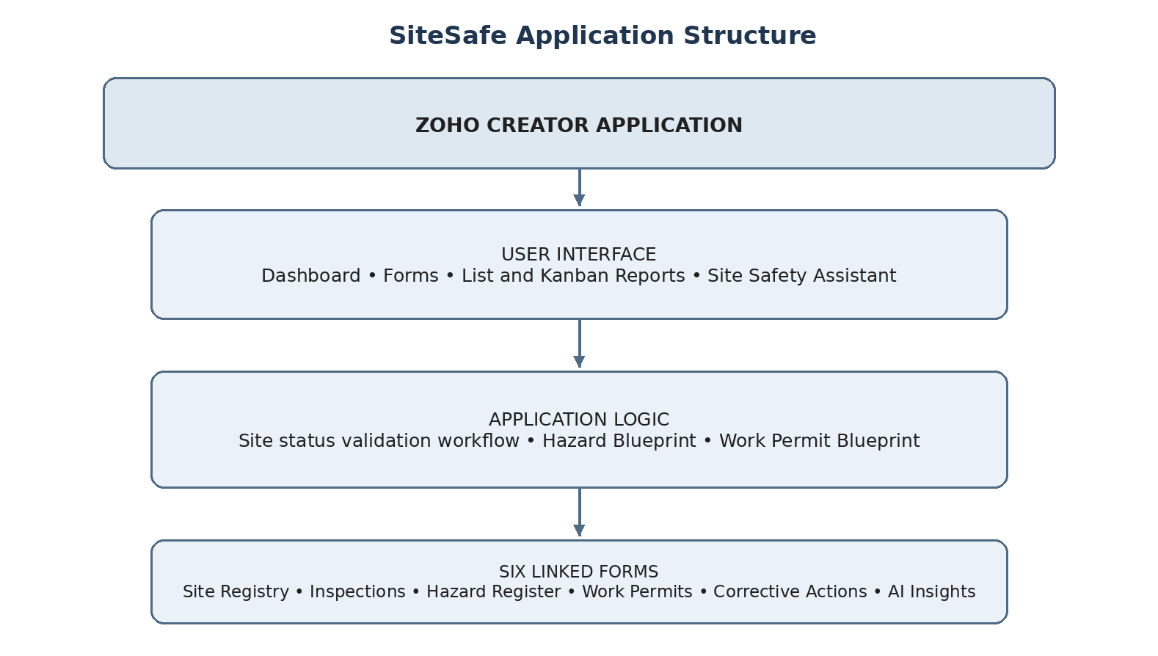
Figure 4.1: System Architecture of the Application

4.2 Data Model and ER Design
The data model uses six forms with lookup relationships among sites, inspections, hazards, actions, permits and insights. Site Registry acts as a master record for construction locations. Hazard Register and Safety Inspections link operational observations to a site. Corrective Action Tracker links remedial work to a hazard. Work Permit Management links permit requests to a site. AI Insights Log stores generated insights with references to relevant site and hazard records.
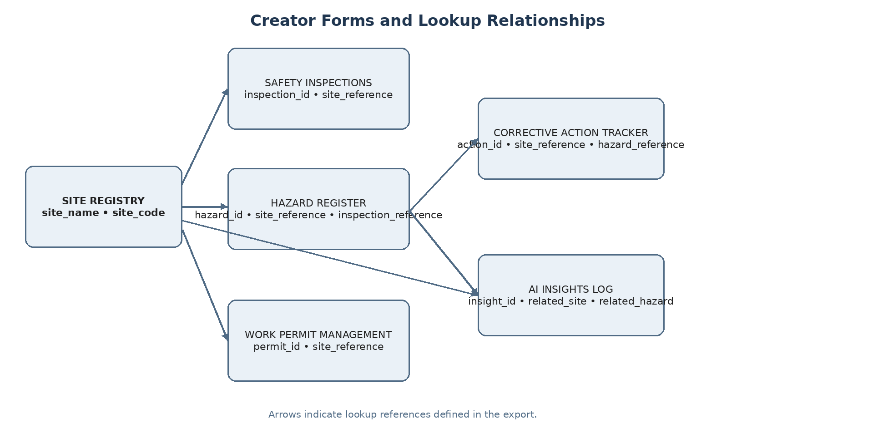
Figure 4.2: Entity–Relationship Diagram
Entity (Form) | Key Identifying Fields | Related Entity / Relationship | Realisation Method
Site Registry | site_code, site_name | Safety Inspections, Hazard Register, Work Permits, Corrective Actions, AI Insights | Referenced by site lookup fields
Hazard Register | hazard_id, hazard_description | Safety Inspections and Corrective Actions | Inspection lookup; hazard lookup
Safety Inspections | inspection_id, inspection_date | Site Registry; Hazard Register | Site lookup; hazard can reference inspection
Corrective Action Tracker | action_id, action_description | Site Registry and Hazard Register | Site and hazard lookups
Work Permit Management | permit_id, work_type | Site Registry | Site lookup
AI Insights Log | insight_id, generated_date | Site Registry and Hazard Register | Related-site and related-hazard lookups

4.3 Form Specifications

4.3.1 Site Registry Form
Field Label | Link Name | Field Type | Mandatory / Constraints
Site Name | site_name | Single Line Text | Yes; construction site name
Site Location | site_location | Address | Yes; geolocation enabled
Project Manager | project_manager | Name | Yes
Safety Officer | safety_officer | Name | Yes
Project Start Date | project_start_date | Date | Yes
Expected Completion | expected_completion_date | Date | Yes; validated target
Site Status | site_status | Picklist | Active, On Hold, Closed, Completed
Overall Safety Status | overall_safety_status | Picklist | Safe, Warning, Critical
Open Hazard Count | open_hazard_count | Number | Dynamic counter
Site Code | site_code | Single Line Text | Yes; unique identifier

4.3.2 Hazard Register Form
Field Label | Link Name | Field Type | Mandatory / Constraints
Hazard Description | hazard_description | Text Area | Yes
Hazard Category | hazard_category | Picklist | Physical, Psychosocial, Chemical, Ergonomic, Biological
Potential Consequence | potential_consequence | Text Area | Yes
AI Risk Level | ai_risk_level | Picklist | High, Low, Medium, Critical
AI Risk Explanation | ai_risk_explanation | Text Area | Optional
Preventive Action | recommended_preventive_action | Text Area | Yes
Assigned Person | assigned_person | Name | Yes
Priority | priority | Picklist | High, Low, Medium, Critical
Date Reported | date_reported | Date | Open, In Progress, Resolved, Verified, Closed
Status | status | Picklist | Open, In Progress, Resolved, Verified, Closed
Resolution Evidence | resolution_evidence | URL | Optional; image evidence link
Site Reference | site_reference | Lookup | Yes; Site Registry
Hazard ID | hazard_id | Single Line Text | Yes; tracking ID

4.3.3 Work Permit Management Form
Field Label | Link Name | Field Type | Mandatory / Constraints
Work Type | work_type | Picklist | Hot Work, Confined Space Entry, Electrical Isolation, Working at Heights, Excavation, Lifting Operations
Work Location | work_location | Single Line Text | Yes
Requested By | requested_by | Name | Yes
Work Start DateTime | work_start_datetime | DateTime | Yes
Work End DateTime | work_end_datetime | DateTime | Yes
Hazard Assessed | hazard_assessment_completed | Checkbox | Yes
Precautions Verified | required_precautions_verified | Checkbox | Yes
Documents Verified | required_documents_verified | Checkbox | Submitted, Draft, Active, Closed, Approved, Expired, Rejected
Permit Status | permit_status | Picklist | Draft, Submitted, Approved, Active, Expired, Rejected, Closed
Site Reference | site_reference | Lookup | Yes
Permit ID | permit_id | Single Line Text | Yes

4.3.4 Safety Inspections, Corrective Action Tracker and AI Insights Log
The supplied project design identifies these three forms as part of the six-form data model. Safety Inspections stores site audit records and checklist results; Corrective Action Tracker stores remedial tasks associated with hazards; AI Insights Log stores generated safety insights and their related site or hazard references. The supplied .ds export includes field definitions for these forms. This section summarises their purpose and relationships; the exported field names remain the reference for detailed implementation.

4.4 Process and Workflow Design

4.4.1 Automated Site Risk Evaluation
When a Site Registry record is added or edited, the Deluge workflow evaluates the open_hazard_count and assigns an overall safety status. A count of zero maps to Safe, a count from one to three maps to Warning, and a count above three maps to Critical.
Open Hazard Count | Computed Site Safety Status
0 | Safe
1–3 | Warning
> 3 | Critical

4.4.2 Hazard Resolution Blueprint
The Hazard Blueprint governs the progression of a reported hazard through assignment, review, mitigation planning, escalation where necessary, resolution, verification and closure.
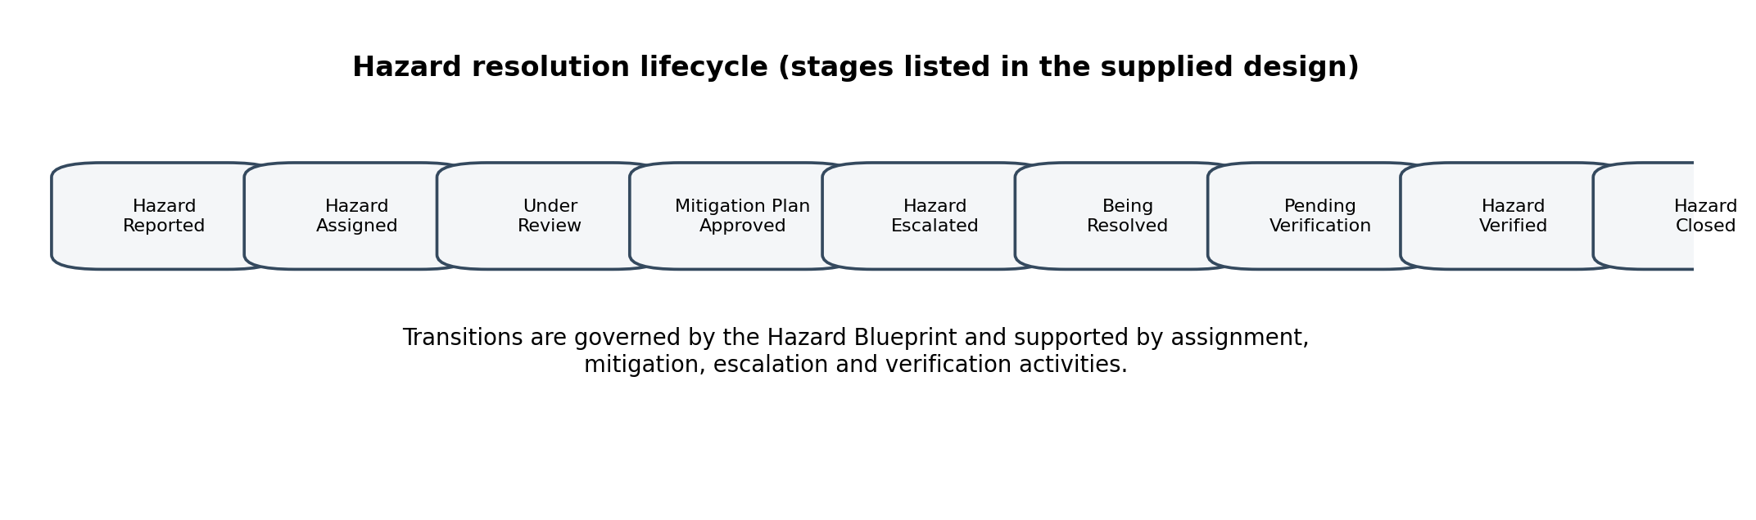
Figure 4.3: Hazard Resolution Lifecycle

4.4.3 Work Permit Blueprint
The Work Permit Blueprint governs the permit request, document verification, safety assessment, approval, activation, work execution, completion and closure.
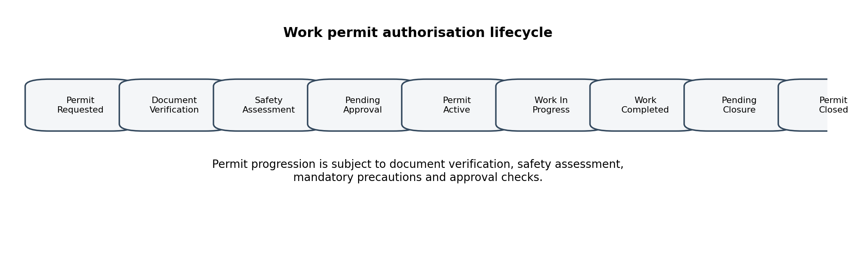
Figure 4.4: Work Permit Authorisation Lifecycle
The exported Hazard Register Blueprint lists ten stages, and the Work Permit Blueprint lists eleven stages; these counts are taken directly from the .ds file.

4.5 User Interface and Navigation Design
The application uses a responsive layout with navigation sections for the Dashboard, Hazard Registers, Corrective Action Trackers, AI Insights Log, Site Registries, Work Permit Management and Safety Inspections. The Site Safety Assistant is available as a conversational interface.
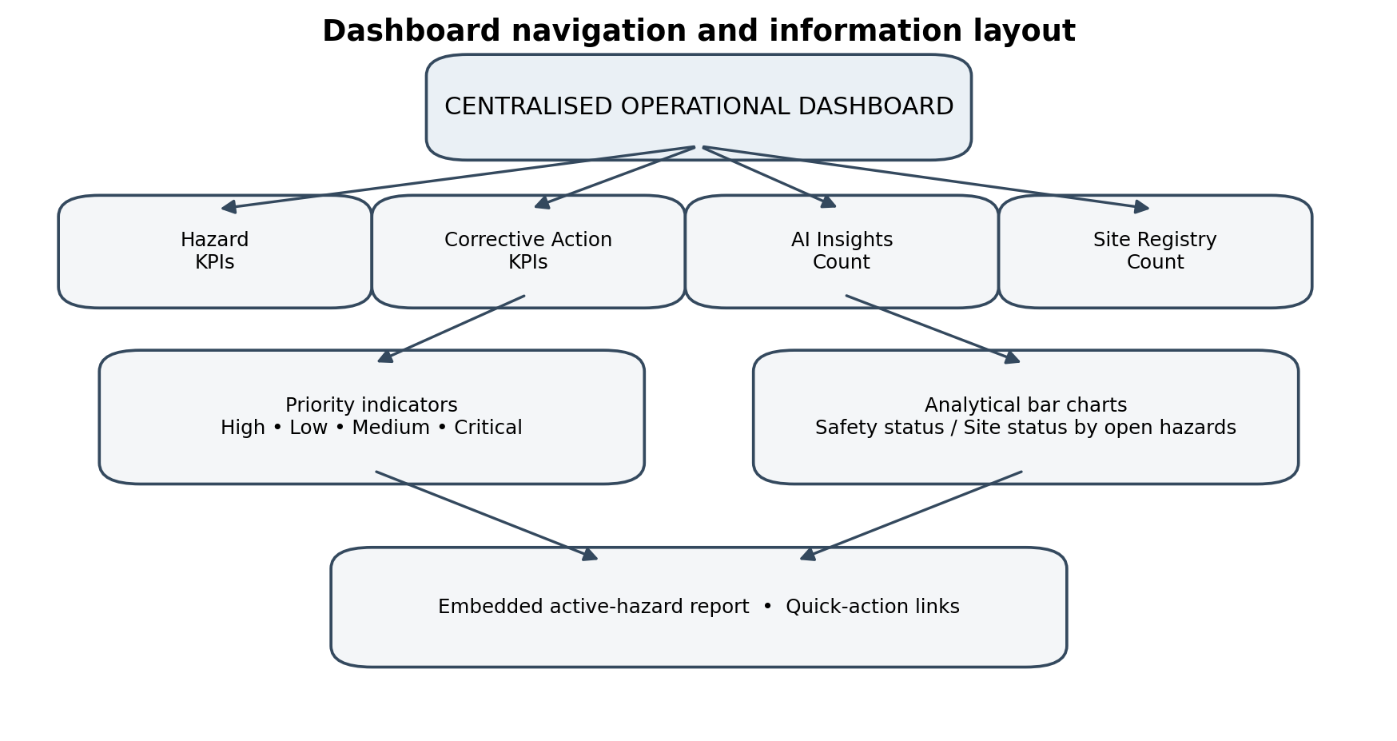
Figure 4.5: Dashboard Navigation and Information Layout

4.6 Access Control and Security Design
The export defines Administrator, Compliance Auditor, Site Safety Manager, Safety Officer, Developer, Permit Coordinator, Project Manager, Contractor and Customer profiles. Module permissions vary by profile; the exact runtime enforcement should be verified in the live application.
Application Component | Administrator | Site Safety Mgr | Safety Officer | Compliance Auditor | Permit Coordinator | Project Manager | Contractor
Site Registry | Add/Edit/View/Delete | Edit/View | View | View | View | View | Restricted
Hazard Register | Full | Edit/View | Add/Edit/View | View | View | View | Assigned records
Safety Inspections | Full | View | Add/Edit/View | View | View | View | Restricted
Work Permit Mgmt | Full | Edit/View | View | View | Add/Edit/View | View | Submit/View
Corrective Action Tracker | Full | Edit/View | View | View | View | View | Assigned actions
Dashboard | Full View | Full View | View | View | View | View | Restricted

The matrix summarises the module and report permissions encoded in the export. Actual access should be checked with users assigned to each profile.

CHAPTER 5
IMPLEMENTATION ON ZOHO CREATOR

5.1 Application Setup
The export identifies a Zoho Creator application configuration named SiteSafe Construction Safety System. The configuration uses the dd-MMM-yyyy dates, 24-hour time and the America/Los_Angeles time zone. The export defines a Zoho Creator application; specific device layouts are not documented.

5.2 Forms and Data Model Implementation
Six forms were configured to represent the main safety-management entities. Text areas support detailed hazard and action descriptions. Picklists provide structured hazard categories and permit types. Lookup fields connect operational records to master site records, inspections and related hazards. The form model is intended to reduce duplicate entry and support traceability between safety activities.

5.3 Reports and Dashboard Implementation
Report Name | View Type | Underlying Form | Primary Purpose
hazard_register_Report | List | hazard_register | Historical hazard log with category formatting.
hazard_register_by_hazard_category | Kanban | hazard_register | Board grouped by hazard category.
corrective_action_tracker_Report | List | corrective_action_tracker | Remedial action log with priority formatting.
corrective_action_tracker_by_priority | Kanban | corrective_action_tracker | Task distribution by priority.
site_registry_Report | List | site_registry | Site directory with map links.
site_registry_by_site_status | Kanban | site_registry | Site status overview.
work_permit_management_Report | List | work_permit_management | Work permit registry and validity tracking.
work_permit_management_by_permit_status | Kanban | work_permit_management | Permit stage tracking board.
safety_inspections_Report | List | safety_inspections | Inspection records and evidence.
safety_inspections_by_inspection_category | Kanban | safety_inspections | Inspection records organised by category.
AI Insights Log report | List | ai_insights_log | AI-generated insight records.
AI Insights Log category/status view | Kanban | ai_insights_log | Visual grouping of insight records.

The dashboard includes four count panels for hazard registers, corrective actions, AI insights and sites, priority counters, quick links, two bar charts and an embedded hazard report. Values are based on Creator form records; the export contains no sample records or captured metric values.

5.4 Workflow and Blueprint Implementation
The only explicit Deluge workflow in the export runs on validation when a Site Registry record is added or edited. It assigns Safe for zero open hazards, Warning for one to three, and Critical for more than three. The Hazard Register Blueprint lists ten stages and the Work Permit Blueprint lists eleven stages. No scheduled workflow is present in the export.

5.5 Deluge Scripting
The following script represents the supplied logic for assigning a site safety status from the open-hazard count.
// Workflow: Auto-Set Site Safety Status
// Form: site_registry | Event: on add or edit -> on validate
siteRecord = site_registry[ID == input.ID];
openHazardCount = input.open_hazard_count;
if(openHazardCount == 0)
{
siteRecord.overall_safety_status = "Safe";
}
else if(openHazardCount > 0 && openHazardCount <= 3)
{
siteRecord.overall_safety_status = "Warning";
}
else if(openHazardCount > 3)
{
siteRecord.overall_safety_status = "Critical";
}
update siteRecord
[
overall_safety_status = siteRecord.overall_safety_status
];
info "Updated safety status for: " + siteRecord.site_name
+ " to " + siteRecord.overall_safety_status;

(DS-01: Auto-Set Site Safety Status Deluge Logic)

5.6 Integration Status
The supplied .ds export contains no Zoho CRM connection or CRM workflow. Contractor/contact synchronisation is therefore not described as implemented.
No external integration workflow or code is present in the supplied .ds export.

5.7 Conversational AI and Assistant Setup
The application defines a conversational assistant named Site Safety Assistant with read/write access to the Hazard Register, Safety Inspections, Corrective Action Tracker and Site Registry. Its instructions cover record operations and summaries while excluding application configuration. AI-labelled fields and an AI Insights Log form are present; the export does not show a model call, structured hazard-analysis action, risk-scoring engine or AI approval workflow.

5.8 User Roles and Security Configuration
The export defines Administrator, Compliance Auditor, Site Safety Manager, Safety Officer, Developer, Permit Coordinator, Project Manager, Contractor and Customer profiles. The Developer and Customer profiles are platform profile types; role-specific module permissions are detailed for the operational profiles. Permissions are applied to application components based on the responsibilities described in Section 4.6. Contractors are restricted from modifying audit criteria and unrelated site configuration.

CHAPTER 6
TESTING AND DEBUGGING

6.1 Test Strategy
The supplied export does not include test cases, test results, sample records or user acceptance evidence. Verification should cover lookup relationships, the site-status workflow, Blueprint transitions, dashboard rendering and profile restrictions.

6.2 Verification Cases and Evidence Status
TC ID | Requirement | Test Description | Expected Result | Actual Result | Status
TC-01 | FR-01 | Create a site with location and dates. | Record saved and listed in Site Registry. | Not run; no execution evidence in export. | Not run
TC-02 | FR-02 | Submit an inspection with checklist results and photos. | Audit logged and available for hazard tracking. | Not run; no execution evidence in export. | Not run
TC-03 | FR-04 | Set open hazards to 0. | Site status becomes Safe. | Not run; no execution evidence in export. | Not run
TC-04 | FR-04 | Set open hazards to 2. | Site status becomes Warning. | Not run; no execution evidence in export. | Not run
TC-05 | FR-04 | Set open hazards to 5. | Site status becomes Critical. | Not run; no execution evidence in export. | Not run
TC-06 | FR-06 | Advance permit without verifying precautions. | Blueprint blocks transition. | Not run; no execution evidence in export. | Not run
TC-07 | FR-07 | Register contractor and inspect CRM Contacts. | Not verifiable from supplied export. | Not run; no execution evidence in export. | Not run
TC-08 | FR-09 | Open dashboard as an active user. | Panels, charts and counters render. | Not run; no execution evidence in export. | Not run
TC-09 | NFR-02 | Attempt site registry modification as Contractor. | Access restricted by permissions. | Not run; no execution evidence in export. | Not run

6.3 User Acceptance Testing
No user acceptance records are included in the supplied export. A live review with Safety Officers, Permit Coordinators, Project Managers and Contractors remains necessary to validate usability and permissions.

6.4 Debugging and Defect Log
Defect ID | Description | Root Cause | Resolution Applied | Status
No defect record in export | Not evidenced | Not evidenced | Not evidenced | Not evidenced
No defect record in export | Not evidenced | Not evidenced | Not evidenced | Not evidenced

CHAPTER 7
DEPLOYMENT, OPTIMISATION, SECURITY AND GOVERNANCE

7.1 Deployment and Environment Strategy
The .ds export identifies a Zoho Creator application configuration named SiteSafe Construction Safety System. It does not establish publication status, live deployment, runtime validation or promotion between environments.

7.2 Performance Optimisation
- Selective Field Fetching: The exported workflow queries a site record by its ID before updating its overall safety status.
- Targeted Dashboard Queries: Dashboard counters aggregate key metrics from operational form fields.
- Clean UI Layouts: List and Kanban reports use status and priority groupings to make records easier to review.

7.3 Security and Governance Controls
- Role Permissions: The export defines module-level permissions for the named operational profiles.
- External Integrations: No external connection or credential configuration is present in the supplied export.
- Audit Trails and Logging: The export defines status, reviewer and verification fields and Blueprint stages. It does not include a separate audit-log form or demonstrate audit-trail settings.

CHAPTER 8
RESULTS AND DISCUSSION

8.1 Achievement of Objectives
Planned Objective | Implemented Component | Documented Evidence
Six-form relational safety architecture | Six forms with lookup relationships | Chapter 4.3; Tables 4.2–4.4
Site safety status classification | Deluge workflow based on entered open-hazard count | Chapter 5.5; Script DS-01
Stage-gated hazard and permit lifecycles | Hazard and Work Permit Blueprint stages | Chapter 5.4
Centralised dashboard and analytics | Dashboard page, KPI panels, charts and reports | Chapter 5.3; Table 5.1
Contractor data integration | Not present in supplied export | No external connection in .ds file
Interactive safety assistance | Assistant definition and AI-labelled data fields | Assistant instructions and AI Insights Log form

8.2 Comparison with the Existing System
Operational Aspect | Existing Manual System | SiteSafe Construction Safety System
Data Logging | Paper logs, clipboards and local spreadsheets | Centralised cloud forms with location and image fields
Site Safety Evaluation | Subjective and delayed reviews | Site safety status mapped from the open-hazard count during site validation
Work Permit Control | Paper approvals with risk of skipped checks | Multi-stage Blueprints with mandatory verification gates
Contractor Oversight | Disconnected contact records | Contractor information is maintained in application records; CRM synchronisation is not shown
Operational Visibility | Fragmented files and archives | Dashboard metrics, charts and Kanban reports

8.3 Discussion of Results
The exported configuration centralises six safety-related forms and presents record counts, priority counters, charts and a hazard report on its dashboard. A site-status workflow maps the entered open-hazard count to Safe, Warning or Critical when a site record is validated. The export does not establish live record volumes, runtime behaviour or external synchronisation.

8.4 Limitations
- Runtime Constraints: The export does not identify the Creator edition, execution quotas or deployment environment.
- Connectivity: The export defines a site address with coordinate capture and evidence URL fields; offline behaviour is not specified.
- Evidence Handling: Inspection photo evidence and resolution evidence are represented as URL fields in the export.
- Implementation Evidence: The export specifies all six forms and lists ten Hazard Register Blueprint stages and eleven Work Permit Blueprint stages. Live runtime behaviour remains unverified.

8.5 Low-Code Reflection
The export illustrates how visual form design, lookup fields, Blueprints and a Deluge workflow can represent construction safety processes on a low-code platform. The configuration also shows why project documentation should distinguish exported definitions from live, tested behaviour.

CHAPTER 9
CONCLUSION AND FUTURE ENHANCEMENTS

9.1 Conclusion
The SiteSafe Construction Safety System centralises construction safety management on the Zoho Creator low-code platform. The exported configuration brings site registries, hazard logs, safety inspections, work permits, corrective actions and AI insight records into one Creator application. Lookup fields, a site-status workflow, Blueprints, reports, role profiles and an assistant definition describe the intended operating structure. Live behaviour and integrations are not established by the export.

9.2 Future Enhancements
- Wearable and IoT Telemetry: Integrate MQTT data streams from worker wearables and environmental sensors into safety dashboards.
- Offline Mobile Caching: Support offline inspection entry with background synchronisation when connectivity returns.
- AI Computer Vision for PPE: Connect image-recognition models to identify missing protective equipment from uploaded photographs.

9.3 Learning Outcomes and Career Pathways
Developing SiteSafe provides an opportunity to apply relational data modelling, event-driven workflow design, lifecycle governance and role-based configuration on a low-code platform. The exported project includes linked forms, one Deluge validation workflow, two Blueprints, reports, a dashboard and an assistant configuration. These concepts are relevant to low-code application development and business-process automation.

REFERENCES
[1] A. C. Bock and U. Frank, “Low-Code Platform,” Business & Information Systems Engineering, vol. 63, no. 6, pp. 733–740, 2021.
[2] Zoho Corporation, “Zoho Creator Developer Guide & Deluge Reference,” 2026. [Online]. Available: https://www.zoho.com/creator/help/
[3] M. Waszkowski, “Low-code platform for automating business processes in manufacturing,” IFAC-PapersOnLine, vol. 52, no. 10, pp. 376–381, 2019.
[4] D. Di Ruscio, D. Kolovos, J. de Lara, A. Pierantonio, M. Tisi, and M. Wimmer, “Low-code development and model-driven engineering: Two sides of the same coin?” Software and Systems Modeling, vol. 21, pp. 437–446, 2022.
[5] Zoho Corporation, “Deluge Tasks and Functions,” Zoho Creator Help. [Online]. Available: https://www.zoho.com/creator/help/

APPENDIX A – ZOHO CREATOR FEATURE COVERAGE CHECKLIST
The following checklist summarises the Zoho Creator features identified in the supplied project description. The implementation status should be confirmed against the live application before submission.
Unit | Zoho Creator Feature | Implemented | Location in SiteSafe / Report
I | Application creation and navigation | Yes | Six forms, reports and dashboard – Chapter 5.1
II | Forms with diverse field types | Yes | Text, Address, Picklists, Checkboxes and Lookups – Chapters 4.3, 5.2
II | Lookup fields / relational links | Yes | Site, hazard and inspection references – Chapters 4.2, 5.2
II | Field validation / layout rules | Yes | Blueprint transition checks – Chapter 5.4
II | List reports | Yes | Hazard, corrective action, site, permit and inspection reports – Chapter 5.3
II | Kanban reports | Yes | Category, priority and status boards – Chapter 5.3
II | UI Builder dashboard | Yes | Dashboard with KPI panels, charts and quick links – Chapter 5.3
II | Deluge form event scripting | Yes | Site-status validation workflow – Chapter 5.5; no CRM task is shown
II | Multi-stage Blueprints | Yes | Hazard and Work Permit lifecycles – Chapter 5.4
III | External service integration | Not shown | No external Zoho integration appears in the export
III | Role-Based Access Control | Configured | Operational profiles plus Developer and Project Manager – Chapters 4.6, 5.8
III | Conversational AI assistant | Yes | Site Safety Assistant – Chapter 5.7
IV | Security and audit logging | Configured fields/profiles only | No separate audit-log form or audit configuration is shown

Note: Feature status is based on the supplied export. Items that require runtime evidence are identified for verification rather than marked complete.

APPENDIX B – COURSE OUTCOME MAPPING
CO | Course Outcome Statement | Evidenced In | Attainment Level
CO1 | Explain principles and architecture of low-code platforms using Zoho Creator. | Chapters 1 and 2 | Not assessed
CO2 | Build business applications using forms, reports, workflows and Deluge scripting. | Chapters 4, 5 and 6 | Not assessed
CO3 | Integrate Zoho Creator applications with Zoho services and role-based security. | Role profile configuration; external integration not evidenced | Not assessed
CO4 | Deploy, secure and govern low-code applications across operational lifecycles. | Deployment status not established by export | Not assessed
CO5 | Evaluate low-code strategies, AI assistance and transitions to professional development. | Chapters 5.7, 8 and 9 | Not assessed

APPENDIX C – COMPLETE DELUGE SOURCE CODE

C.1 Auto-Set Site Safety Status (DS-01)
// Script ID : DS-01
// Location : site_registry Form -> Workflow -> On Validate
// Purpose : Assign overall safety status from open hazard count
siteRecord = site_registry[ID == input.ID];
openHazardCount = input.open_hazard_count;
if(openHazardCount == 0)
{
siteRecord.overall_safety_status = "Safe";
}
else if(openHazardCount > 0 && openHazardCount <= 3)
{
siteRecord.overall_safety_status = "Warning";
}
else if(openHazardCount > 3)
{
siteRecord.overall_safety_status = "Critical";
}
update siteRecord
[
overall_safety_status = siteRecord.overall_safety_status
];
info "Updated overall safety status for site: "
+ siteRecord.site_name + " to "
+ siteRecord.overall_safety_status;

C.2 Additional Workflows
No additional Deluge workflow is included in the supplied .ds export.

The supplied .ds export contains one Deluge workflow: the site safety status calculation. No other Deluge scripts are included in this export.

APPENDIX D – USER MANUAL

D.1 Accessing the Application
- Open the SiteSafe application from an authorised Zoho Creator workspace. The export does not establish a published application URL.
- Sign in using the assigned Zoho organisational account credentials.
- After authentication, use the Dashboard to review active sites, hazards and safety metrics.

D.2 Instructions for Safety Officers
- Conducting an Inspection: Open Safety Inspections, select Add Safety Inspection, choose the target site and inspection category, record the result and attach photo evidence.
- Logging a Hazard: Open Hazard Registers, select Add Hazard Register, choose the site reference and hazard category, set priority, and enter the hazard description and preventive action.
- Tracking Progress: Open the relevant Kanban view to review records grouped by category, priority or status.

D.3 Instructions for Site Safety Managers
- Monitoring Site Health: Review dashboard metrics and site statuses (Safe, Warning, Critical).
- Reviewing Work Permits: Open Work Permit Management and verify that safety assessments and required documents are complete before approval.
- Using the Site Safety Assistant: Open the assistant for the record operations and summaries described in its configuration. The export does not show automated risk analysis.

D.4 Instructions for Contractors and Permit Coordinators
Contractors use the available permit and assigned-action views to submit requests and provide resolution evidence. Permit Coordinators review the submitted information and move the permit through the configured verification and approval stages.

APPENDIX E – EVALUATION RUBRIC
(For Examiner Use Only)
Student Name: VINESH D Register No.: 240701590
Project Title: SiteSafe Construction Safety System
Date of Examination: ______________________________
S.No. | Criterion | Indicators | Max Marks | Marks Awarded
1 | Problem Definition and Requirements | Problem clarity, measurable objectives, complete FR/NFRs | 10
2 | System Design | Architecture, ER design, form specifications, RBAC matrix | 10
3 | Forms, Reports and Dashboard | Form structure, lookups, Kanban reports and dashboard | 15
4 | Deluge Scripting and Workflows | Business logic, Deluge validation and Blueprints | 15
5 | Role permissions, conversational assistant; external AI/CRM integrations are not shown | Zoho CRM sync not in supplied export, role permissions and conversational AI | 10
6 | Testing, Security and Governance | Test coverage, defect log and security controls | 10
7 | Live Demonstration | End-to-end demo across multiple user roles | 15
8 | Project Report Adherence | Template, formatting, figures and references | 5
9 | Viva-Voce Performance | Technical understanding of low-code concepts and Deluge | 10
 | TOTAL |  | 100

Signature of Internal Examiner: ______________________________
Signature of External Examiner: ______________________________

APPENDIX E – EVALUATION RUBRIC
(For Examiner Use Only)
Student Name | Vinesh D | Register No. | 240701590
Project Title | SiteSafe Construction Management System | Date | __________________

Table E.1: Evaluation Rubric for the Individual Project
S.No. | Criterion | Indicators | Max. Marks | Marks Awarded
1 | Problem Definition & Requirement Analysis | Clarity of problem, measurable objectives, complete FR/NFR, use cases | 10
2 | System Design | Architecture, ER/data model, form specifications, workflow design, permission matrix | 10
3 | Forms, Reports & Pages | Variety of field types, lookups/subforms, report types, UI Builder dashboards | 15
4 | Deluge Scripting & Workflows | Correctness and depth of scripts; form, schedule, approval, Blueprint, batch workflows | 15
5 | Integration, RBAC & AI | Zoho/external integrations, connections, roles & permissions, Zia/analytics | 10
6 | Testing, Deployment, Security & Governance | Test coverage, environments, optimisation, security controls, audit | 10
7 | Live Demonstration | End-to-end working of the application across roles; feature checklist verified | 15
8 | Project Report | Adherence to template and format, clarity, figures, references | 5
9 | Viva-Voce | Understanding of the platform, design decisions and low-code concepts | 10
 | TOTAL |  | 100

Table E.2: Performance Level Descriptors
Level | % of Max. Marks | Descriptor
Excellent | 90–100 | Feature implemented completely, correctly and beyond the basic requirement; student explains design choices confidently.
Good | 70–89 | Feature implemented correctly with minor gaps; explanation adequate.
Satisfactory | 50–69 | Feature partially implemented or works only for the main path; limited explanation.
Needs Improvement | < 50 | Feature missing, non-functional or not understood by the student.

Signature of Internal Examiner  Name: ____________________ | Signature of External Examiner  Name: ____________________

APPENDIX F – VIVA-VOCE RECORD SHEET
(For Examiner Use Only)
Student Name | Vinesh D | Register No. | 240701590
Department / Section | Computer Science and Engineering  Section: ____________________ | Date of Viva | ____________________
Application URL Verified | Yes / No | Demo Duration | ______ min
Table F.1: Viva-Voce Questions and Responses
Q.No. | Question / Topic Asked | Unit | Response (E / G / S / NI) | Remarks
1
2
3
4
5
6
7
8
E – Excellent G – Good S – Satisfactory NI – Needs Improvement
Table F.2: Marks Summary
Component | Max. Marks | Marks Awarded
Criteria 1–8 (Appendix E) | 90
Viva-Voce | 10
TOTAL | 100
Examiners’ Remarks:
________________________________________________________________________________________________________________________________________
INTERNAL EXAMINER  Name: ____________________ | EXTERNAL EXAMINER  Name: ____________________

